This is an optical approach towards character recognition. A parallel beam of light rays is thrown on the character from the top of the image. The character here acts as denser medium with refractive index 1.5(µ2) and that of the background is 1(µ1). At first the data pixels are found out where the light rays strike in first place. Here the character is considered as a glass slab and so the horizontal deviation which we get by glass slab refraction for each ray is taken as our feature. For calculating the horizontal deviation, the local width and local slope are found out and accordingly the lateral shift and horizontal deviation are calculated using the following equations.

where , and .

**Glass slab refraction:**

We know that light traverses in straight line in a medium or two mediums with same density. Now we need to see what happens when it travels through mediums of different densities. So, when this happens light ray bends at the boundary between two mediums. This phenomenon of bending of light ray is known **Refraction of light**. Now when a light ray traverses through a glass slab it suffers a parallel shift or lateral shift after exiting the slab. The first angle of refraction and second angle of refraction are equal as the slab is parallel and so does the angle of incidence and angle of emergence for the same reason.

Lateral displacement is the perpendicular distance between the incident and the emergent rays when the light ray is incident on the slab obliquely.

**Factors on which the lateral displacement depends:**

* Lateral displacement is directly proportional to the thickness of the slab.
* Lateral displacement is directly proportional to the angle of incidence.
* Lateral displacement is directly proportional to the refractive index of the slab.
* Lateral displacement is inversely proportional to the wavelength of the incident light ray.

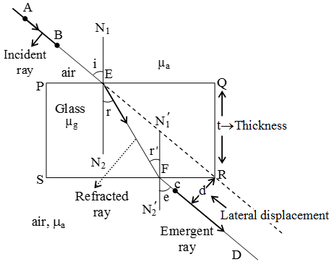

The above image clearly depicts the phenomenon of **glass slab refraction of light**. And the lateral displacement as shown in the figure can be expressed as,

**Local slope and width calculation:**

For slope calculation, the data pixel, on which the light ray first strikes, is found out and taking the horizontal axis as main axis a straight line is rotated from 0°to 360° with an interval of 10° and the corresponding stroke widths are also noted. As we know that perpendicular distance is always minimum, we take the minimum stroke width as our local width and the complementary angle of corresponding angle of rotation is taken as the local slope. Angle of incidence depends on slope.

We have chosen the horizontal deviation as our feature because the deviation will change with slope which will vary from character to character.